TABLE ORDER FORM

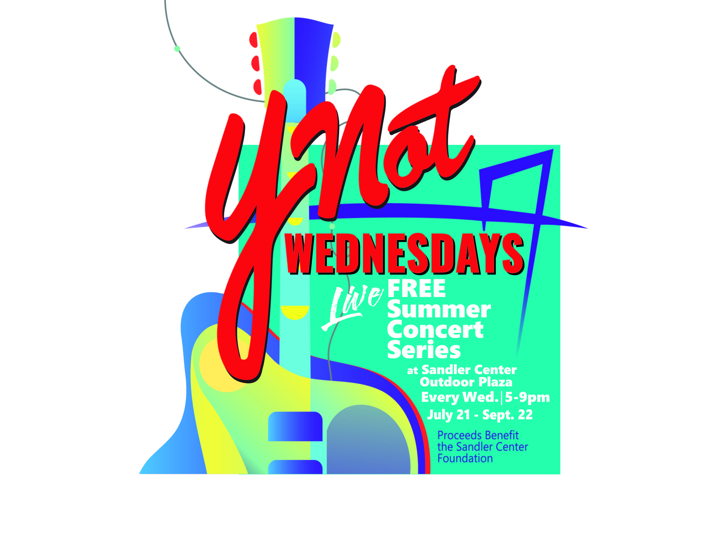

FREE SUMMER CONCERT SERIES IN TOWN CENTER 2021
VIP TABLES
- Seat 8 people
- Includes 16 drink vouchers per week
- Premium viewing location
- Personal table service
- Table display for logo or your occasion's artwork
- $2,150 for the entire series

- July 21
- July 28

- August 4
- August 11
- August 18
- August 25

- September 1
- September 8
- September 15
- September 22

CORPORATE PROMO PACKAGE
- Includes VIP Table for the entire series
- Business recognition during stage announcements each week
- Company banner displayed at each concert
- $3,500 for the entire series
CAFÉ TABLES
- Seat 4 people
- Includes 8 drink vouchers per week
- Convenient shaded location (Where McCormick & Schmick’s is located)
- Personal table service
- Table display for logo or your occasion's artwork
- $1,250 for the entire series

- July 21
- July 28
- August 4
- August 11
- August 18
- August 25

- September 1
- September 8
- September 15
- September 22

PROCEEDS FROM YNOT WEDNESDAYS?
BENEFIT THE SANDLER CENTER FOUNDATION

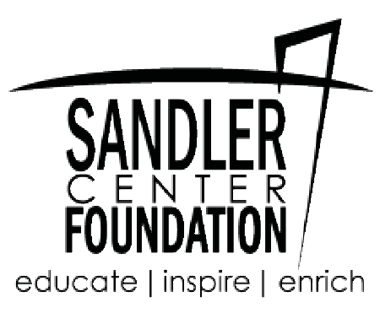

Anticipated sell out! Reserve your table now!
Payment equal to 50% of the VIP Table Reservation is due immediately to hold the reservation. The remainder will be due no later than August 18, 2021.

Contact Name Table Name Contact Phone Number Mailing Address Table Preference
Return this form and 50% balance due (checks made to Global Spectrum LP) to Todd McKeating at 201 Market Street, Virginia Beach, VA 23462. You will be contacted with reservation
confirmation. Please contact Todd for information at 757-385-2528 or tmckeating@sandlercenter.org

