Vendor Order Form

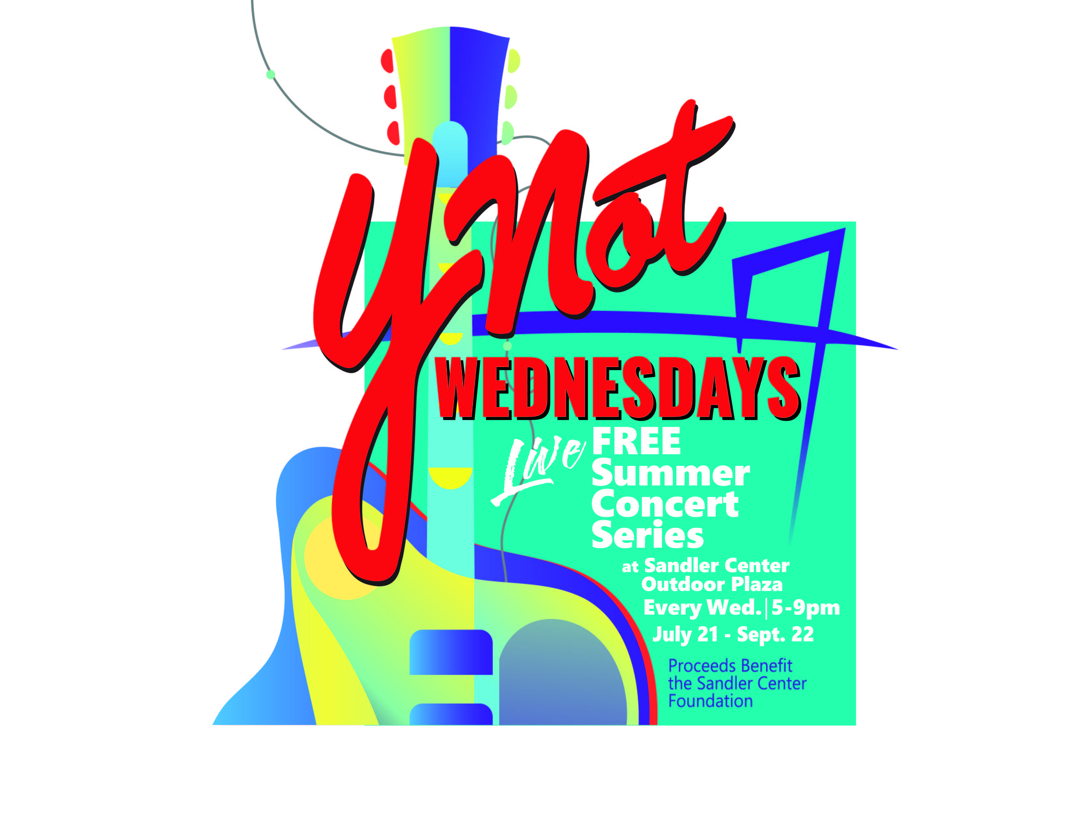

TABLE ORDER FORM
FREE SUMMER CONCERT SERIES IN TOWN CENTER 2021
VENDOR SPACE
- Ability to set up a tent, banners and table
- Permission to sell merchandise
- Distribute promotional materials on the spot
- Acknowledgement from main stage as a promo table sponsor

- $225 per week on Bank St.
- $215 per week on Commerce St.
- July 21
- July 28

- August 4
- August 11
- August 18
- August 25

- September 1
- September 8
- September 15
- September 22

CORPORATE PROMO PACKAGE
- Includes VIP Table for the entire series
- Business recognition during stage announcements each week
- Company banner displayed at each concert
- $3,500 for the entire series
PROMO TABLE
- Table (6 ft.) for display, with black scuba skirting (No tents allowed)
- Ability to set up a table display and hang banner from table display (height not to exceed 6ft. off the ground)
- Ability to distribute promotional materials at table
- Acknowledgement from main stage as a promo table sponsor
- $200 Per Week
- July 21
- July 28
- August 4
- August 11
- August 18
- August 25

- September 1
- September 8
- September 15
- September 22

PROCEEDS FROM YNOT WEDNESDAYS?
BENEFIT THE SANDLER CENTER FOUNDATION

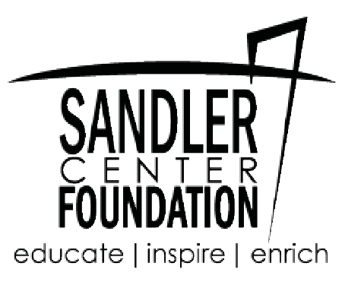

Anticipated sell out! Reserve your table now!
A $100 deposit is required to hold your reservation. This can be applied to the table cost, but is non-refundable if the reservation is cancelled. (Please note if you opt for the Corporate Promo Package, a $200 deposit is required)
Contact Name Email Contact Phone Number Mailing Address Vendor or Prom Table
Return this form and $100 deposit (checks made to Global Spectrum LP) to Todd McKeating at 201 Market Street, Virginia Beach, VA 23462. Credit Card payments are also accepted You will be contacted with reservation
confirmation. Please contact Todd McKeating at 757-385-2528 or tmckeating@sandlercenter.org

